Texas Gulf Coast Orff Association
Orff Instrument Repair Clinic - DIY for the Music Teacher
Everything comes down to time and money. You can repair just about anything.
Presented by Larry Shudra 3/30/19
Larry Shudra’s website- http://www.LarryShudraMusic.wordpress.com
Email- lshudra@sbcglobal.net
I am currently the elementary music in Spring Branch ISD at Westwood Elementary School since 2014. I use a combination of Orff, American Kodaly (Dr. John Feierabend) and some whatever it takes. BME in instrumental music from Baylor University. A former (or reformed-according to Dr. John Feierabend) band director in Cypress Fairbanks ISD for 19 year. 9 years at Hempstead Elementary teaching elementary music and assisting with the Hempstead High school band.
Orff instruments are important in the elementary music education program. I uses them every day. We call them Orff because Carl Orff selected them as a simple instrument for children to create accompaniments to singing. Orff instruments are diatonic xylophones, with bars of wood. Metallophones are made of metal. Caring for wood instruments is just like caring for wood furniture. In this clinic, I am going to show you how to repair, clean, maintain and tune your instruments. I will share a design to create your own Orff carts to roll your instruments safely. I am in the process of designing a cart for contra bass bars that I will post on my website in the future. You may contact me anytime for help with anything about teaching or playing music.
I have never worked in a situation where I could buy what I wanted with the budget I was given ($250 or less per year). The PTA ay my schools are not able to support the music program financially. I have been fortunate to be given the TMEA Elementary Music grant twice, a Target Field Trip Grant, and several Donors Choose projects for a wide variety of instruments and parts. I have also be fortunate to have been given old xylophones from schools that received new instruments and had no room the old ones.
Online Resources
Dr. Lissa Teaching With Orff website has very good videos. https://teachingwithorff.com/category/instrument-repair/
Larry Shudra Orff Repair https://wordpress.com/post/larryshudra.wordpress.com/2325
Larry Shudra Orff Bass Xylo or Metallo cart https://wordpress.com/post/larryshudra.wordpress.com/4134
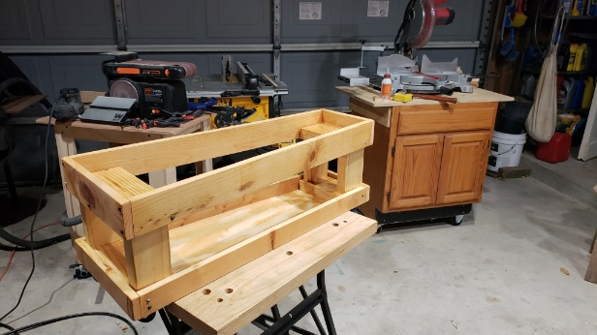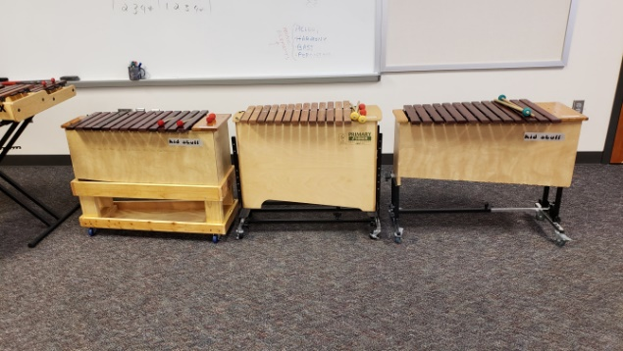
Google search Orff Repair and many resources will pop up. Youtube and search Orff repair and you will find videos as well.
Plan your work ahead. Unless you are in an emergency, (you’re walking on stage and something terrible happens to an instrument that you need) take your time. If you don’t have time to do it right, when are you ever going to have time to do it again.
A Workspace
A countertop, a table or a clear desktop large enough for the instrument, tools, and parts. And a radio or Bluetooth speaker.
Tools
Small hammer
Pliers, Needle Nosed Pliers
Drill, drill bits
Screw Extractor bit (available from Rockler or online)
Dovetail Saw
Rags, micro fiber clothes, paper towels
Wood cleaners – Scots Liquid Gold, Goo Gone, WD 40
Wood polish – Scots Liquid Gold, Minwax Paste wax (light or dark)
Wood glue – Titebond, Elmers, wood glue, not glue all.
Clear caulk
0000 steel wool, sand paper (40 or 60 for removing wood, 240 or higher for smoothing
Gold Sharpie or fine point paint pen
Clamps and thin pieces of scrap wood– for repairing boxes and removing nails
Belt sander or bench top sander

Parts

Order parts for the brand(s), types and age of instruments that you have. New pins/nails, tubing, for xylophones, metallophones and glockenspiel bars.
Where to buy parts:
Know what you have (soprano, alto or bass and what brand). If you know what you need, you can buy parts from Amazon, Woodwind Brasswind, West Music, and other general music vendors.
Kid Stuff-these instruments are actually manufactured in the 1980’s by Suzuki America. You can buy parts and replacement bars from the Suzuki website. The bars are narrow, but if that’s what you have…use ‘em.
Studio 49 – all parts and bars are available from Studio 49 online. You will need to know the year that your instrument was built (approximately).
Peripole Bergerault – Parts and bars online.
Sonor – Parts and Bars available online
RBI – I have not been able to find RBI parts. However you might use another brand part in its’ place.
DIY Parts- You can buy nails, shrink wrap tuning, aquarium air hose, latex hose and paracord to rebuild with. Just take what you have and go to a big box store or wood working shop and look for something like the example that you brought with you.
How To Fix Most Things:
Bent Pins or Nails
If you are careful, you can bend the pins back into place. Once you bend them a few times they will break. But do not worry. They are easily replaced if the pin is still attached you can pull it out with a claw hammer or pliers. Place something under your tool on top of the side of the resonator box. Prying the nail out without that protection will damage the side of the box.
If the pin is broken off, use a screw extractor drill bit. Drill slowly and just as deep as the nail is in the box. A tubular piece will break off with the old nail in it. Take a ¼ inch dowel and glue it into the hole. Cut it off flush with the box using a saw. Sand it flat. (If you use a dovetail saw, it will cut off flush and smooth!). Install your new nail. Done!
Here is a Youtube video on how to do this: https://www.youtube.com/watch?v=LRzCxLumn1w
Tuning
Over time, xylophone bars can go out of tune. In my experience, they tend to go sharp. You will need a strobe tuner, sand paper or belt sander (preferred). You can raise and lower the pitch of a bar by removing wood in different places on the back of the bar. I like to use a strobe tuner because you can see the pitch of the fundamental and the overtones. But, any tuner that responds to a single bar being played will do.
Bill Vyrens in Austrailia has an excellent page on tuning. http://www.musaics.com.au/
There are other online tuning videos from Tom Bourne Marimbas

Resonator Box Repair
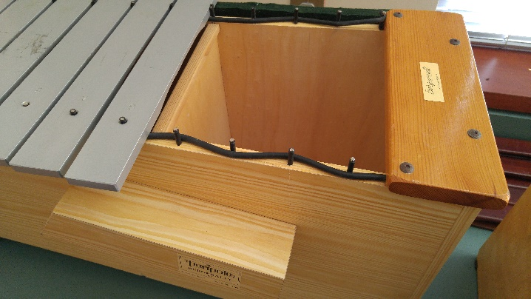
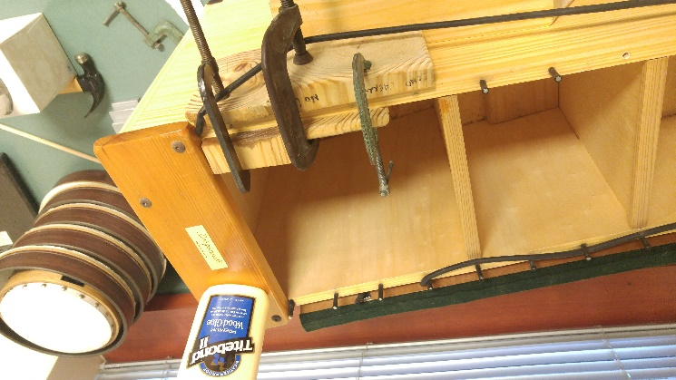

Some boxes can be repaired or even rebuilt. This will depend upon your woodworking skills, tools and time. To me, if the bars are good, and the box needs repair, I would strongly consider repairing the box. However, if you are going to pay someone to repair the box, or rebuild the box, weigh your cost of new verses the repair.

Buzzing sound inside
If parts become loose, they can vibrate sympathetically with certain frequencies. Many time the vibrating object is a partition inside the resonator box. Find it by tapping around with the end of your finger. When you find it, put a bead of clear caulk where the partition meets the walls of the box.
Carry Handle Replacement
If you still have the old piece, clean off the old glue and re glue it using wood glue. You can pre drill a hole and countersink a wood screw. Fill the hole over the screw by gluing in a dowel of the correct diameter. Cut off the dowl. Sand carefully not to ruin the finish. Stain to match and put finish over it (polyurethane, wax, etc).

Best wishes. Keep those children playing and singing!
Larry Shudra

